Topic – list interface part 10 🡪

**Last index of method -**

**IndexOfMethodForIndexNotPresent-**

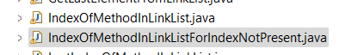

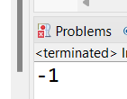

**LastIndexOfMethodOnIndexNotPresent-**

**RemoveMethodInLinkList-**

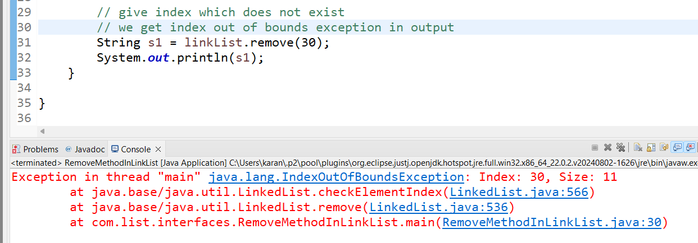

**RemoveFirstMethodLinkList-**

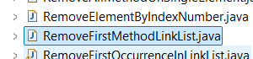

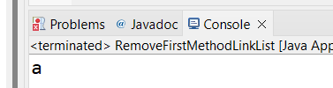

**Remove last method-**

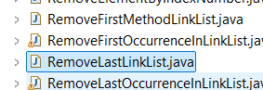

**Remove first occurrence method-**

**Remove last occurrence method-**

**Set method-**

**Poll first method-**

**Poll last method-**

**Array list to link list and vice versa-**

**Add element at specific index-**

**Vector list example-**

**Vector Traversal-**

**Vector traversal example two-**

**Add vector to array list-**

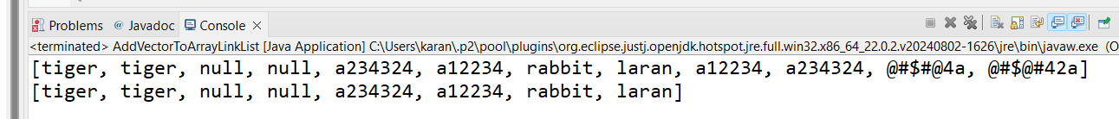

**Convert array list to vector-**

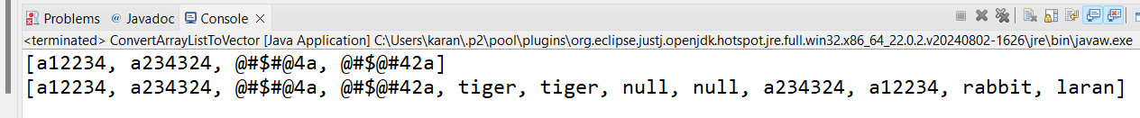

**Stacks example-**

**Directly push into stack-**

**Directly pop from stack-**

**Pop till we get exception from stack to know the exception name-**

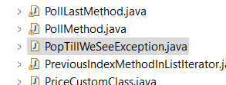

**Search method-**

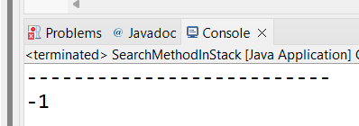

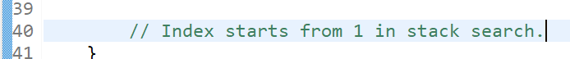

**Is empty method-**

